**ASSIGNMENT 1 FRONT SHEET**

|  |  |  |  |
| --- | --- | --- | --- |
| **Qualification** | **TEC Level 5 HND Diploma in Computing** | | |
| **Unit number and title** | **Unit 04: Database Design & Development** | | |
| **Submission date** |  | **Date Received 1st submission** |  |
| **Re-submission Date** |  | **Date Received 2nd submission** |  |
| **Student Name** | Dinh Ba Thi | **Student ID** | GCH210871 |
| **Class** |  | **Assessor name** |  |
| **Student declaration**  I certify that the assignment submission is entirely my own work and I fully understand the consequences of plagiarism. I understand that making a false declaration is a form of malpractice. | | | |
|  |  | **Student’s signature** |  |

**Grading grid**

|  |  |  |
| --- | --- | --- |
| P1 | M1 | D1 |
|  |  |  |

|  |  |  |
| --- | --- | --- |
| **❒ Summative Feedback: ❒ Resubmission Feedback:** | | |
| **Grade:** | **Assessor Signature:** | **Date:** |
| **Signature & Date:** | | |

Contents

Chapter 1: Statements of user and system requirements. 4

1.1: Overview about the Problem. 4

Our client, a small online retailer, is in need of a new management system for their inventory and sales. The current system is inefficient and lacks key features. The client requires a user-friendly and secure system that can handle the increasing volume of inventory and sales data. 4

1.2Requirements of the application. 4

1. The system must allow users to easily add, modify, and delete products from the inventory. 4

2. The system must track sales transactions and provide reports on revenue, profits, and inventory levels. 4

3. The system must allow customers to purchase products online and track their orders. 4

4. The system must generate invoices and provide customers with automatic updates on the status of their orders. 4

5. The system must have a secure login feature for employees and customers. 4

6. The system must be scalable to handle future growth in the number of products and sales transactions. 4

7. The system must have backup and recovery mechanisms to prevent data loss. 5

8. The system must be accessible from multiple devices and platforms. 5

Chapter 2 – Design the relational database system. 5

2.1 Analyse the requirements. 5

2.2 Physical ERD 6

2.3 Database Design with Explanations: 7

2.4 Review Whether the Database is Normalized: 7

2.5 Data Validation: 8

Reference 8

# Chapter 1: Statements of user and system requirements.

## 1.1: Overview about the Problem.

## Our client, a small online retailer, is in need of a new management system for their inventory and sales. The current system is inefficient and lacks key features. The client requires a user-friendly and secure system that can handle the increasing volume of inventory and sales data.

## 1.2Requirements of the application.

# 1. The system must allow users to easily add, modify, and delete products from the inventory.

# 2. The system must track sales transactions and provide reports on revenue, profits, and inventory levels.

# 3. The system must allow customers to purchase products online and track their orders.

# 4. The system must generate invoices and provide customers with automatic updates on the status of their orders.

# 5. The system must have a secure login feature for employees and customers.

# 6. The system must be scalable to handle future growth in the number of products and sales transactions.

# 7. The system must have backup and recovery mechanisms to prevent data loss.

# 8. The system must be accessible from multiple devices and platforms.

# Chapter 2 – Design the relational database system.

## 2.1 Analyse the requirements.

The database must be designed to handle the inventory, sales, and customer data efficiently. The following entities will need to be represented in the database:

- Products: product ID, name, description, quantity, price, image

- Sales: sale ID, product ID, quantity, date, customer ID

- Customers: customer ID, name, address, contact information

## 2.2 Physical ERD

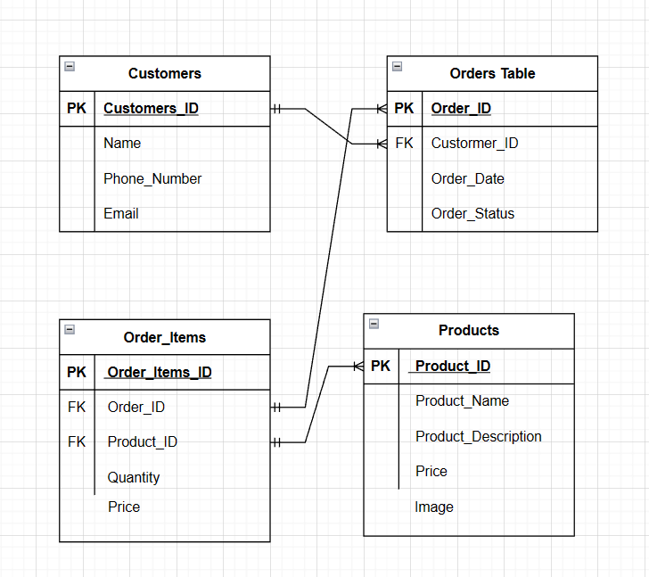

## 2.3 Database Design with Explanations:

We will use a relational database schema to represent the entities in our system. The conceptual data model will consist of four main tables: Customers, order, order_table, order_item, and products. We will use a foreign key to link the Sales and Customers tables to the Products table.

The Customers table will store all the information about each customer, including their first name, last name, phone number, and email. The Orders table will store all the information about each order, including its ID, the customer who placed it (by reference to the Customer_ID foreign key), the date of the order and its status. The Order_Items table will hold all line item of each order, linking the Order_ID and Product_ID foreign keys together by quantity and price.

The Products table will contain all of the information on each product in the database, including its name, description, price, and image. The Product_ID field will be used as a foreign key in the Order_Items table to link individual orders with the specific products they include. The Customer_ID field will be used as a foreign key in the Orders table to relate each order to the specific customer who made it.

This structure will ensure that each customer can place multiple orders, and each order can contain multiple order items, each of which can correspond to a specific product in the database. This way, a comprehensive overview of the customers, orders, and items sold can be maintained.

## 2.4 Review Whether the Database is Normalized:

We will ensure that the database is normalized to avoid data redundancy and anomalies. The database design follows the third normal form (3NF) rules.

## 2.5 Data Validation:

We will use data validation to ensure that the data entered into the system is accurate and valid. This will include data type validation, range validation, and content validation.

# 

# Reference

Freeprojectz, [online] Available at: <https://www.freeprojectz.com/dfd/human-resource-management-systemdataflow-diagram> [Accessed 24 October. 2020]

Freeprojectz,[online] Available at: <https://www.freeprojectz.com/entity-relationship/human-resource-managementsystem-er-diagram> [Accessed 24 October. 2020]

Creately,[online] Available at: <https://creately.com/diagram/example/h88w3c102/HR/Management/System> [Accessed 24 October. 2020]

Why to Learn SQL? , [online] Available at: <https://www.tutorialspoint.com/sql/index.htm> [Accessed 24 October.2020]

Learning SQL, [online] Available at: <https://www.w3schools.com/sql/default.asp> [Accessed 24 October. 2020].

azure.microsoft.com powerful (August 12, 2019).Six ways we’re making Azure reservations even more, [online]Available at: <https://azure.microsoft.com/en-us/blog/6-ways-were-making-azure-reservations-even-more-powerful/> [Accessed 24 October. 2020].